# Lab 6

1: Group Chat App

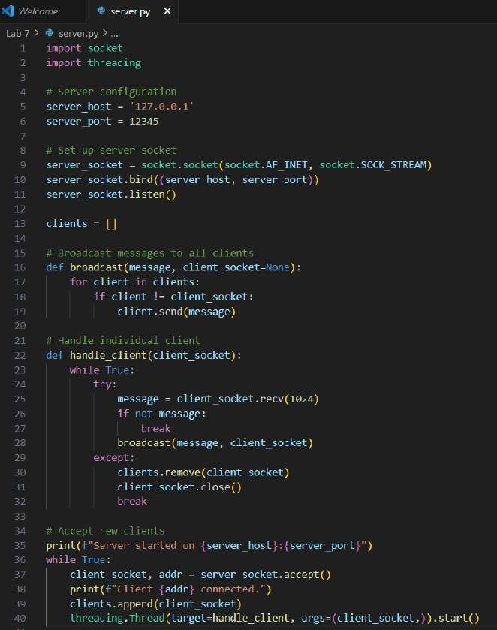Code for server

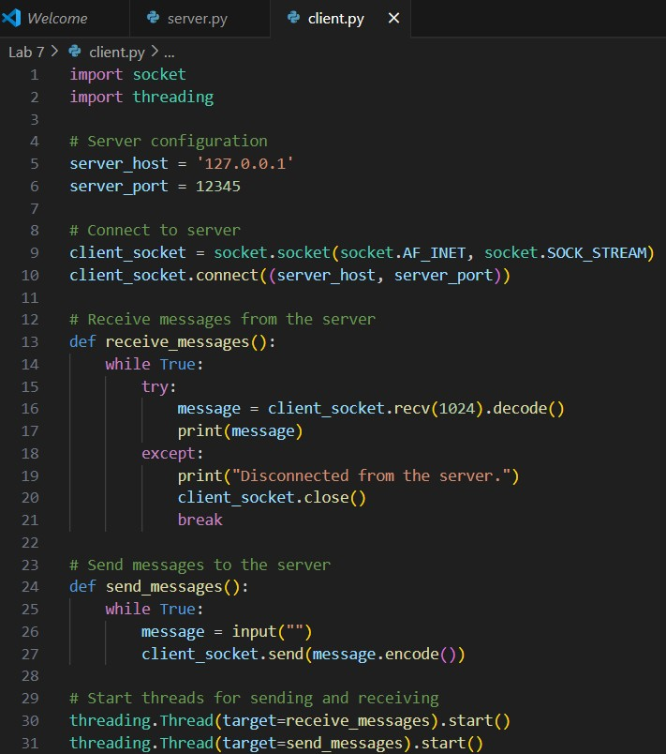Code for client

Output :-

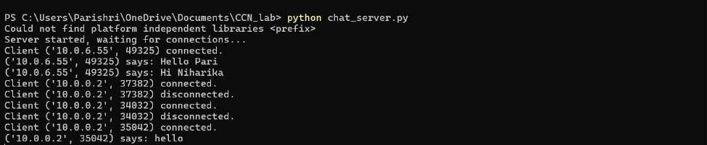I had executed the code for the server. There were 2 clients with IP addresses - ‘10.0.6.55’ and ‘10.0.0.2’.

2: Remote Procedure Calls (RPC)

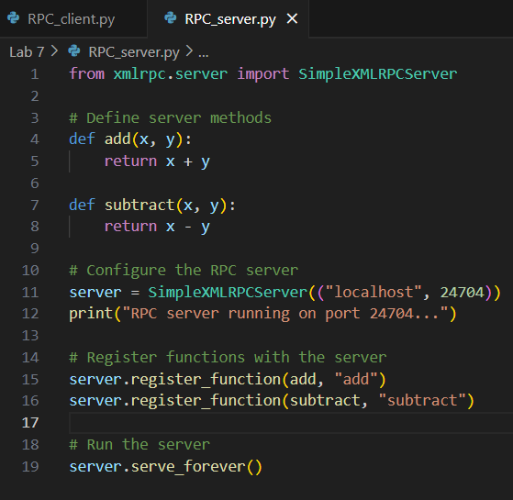Code for server

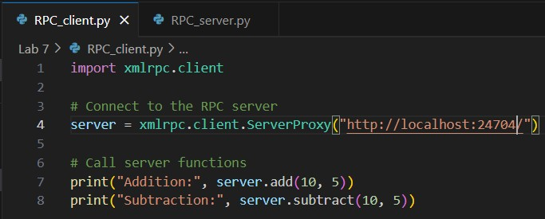Code for Client

Output :-

Hosted the RPC server on port 24704.

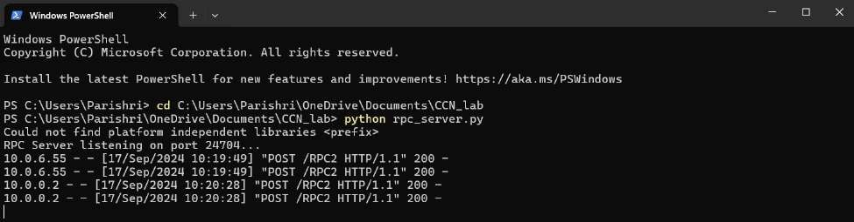

3: Telnet for controlling remote devices

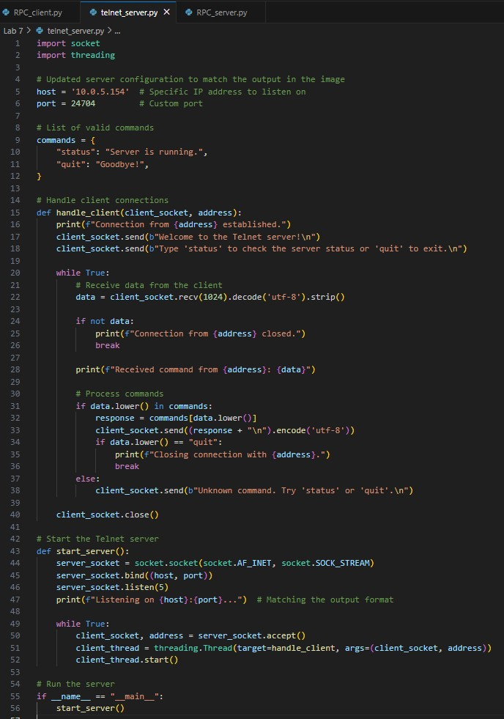Code for server

Output :-

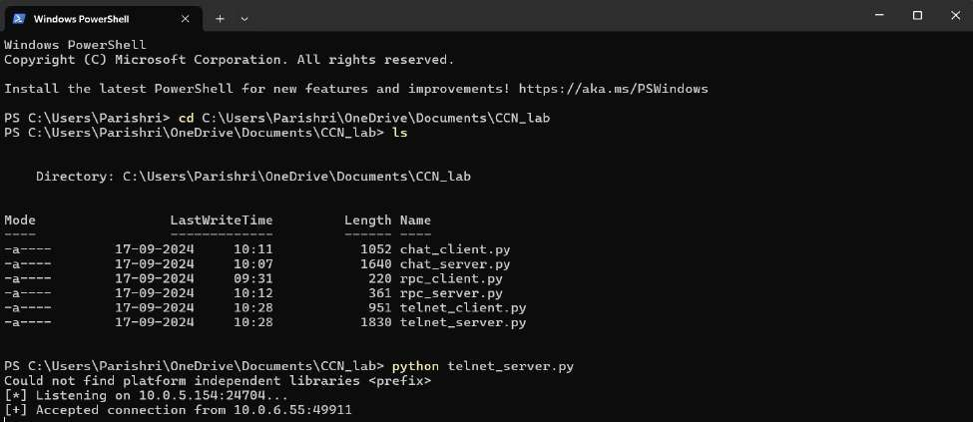The telnet server was listening on IP add1: Group Chat App

Code for server

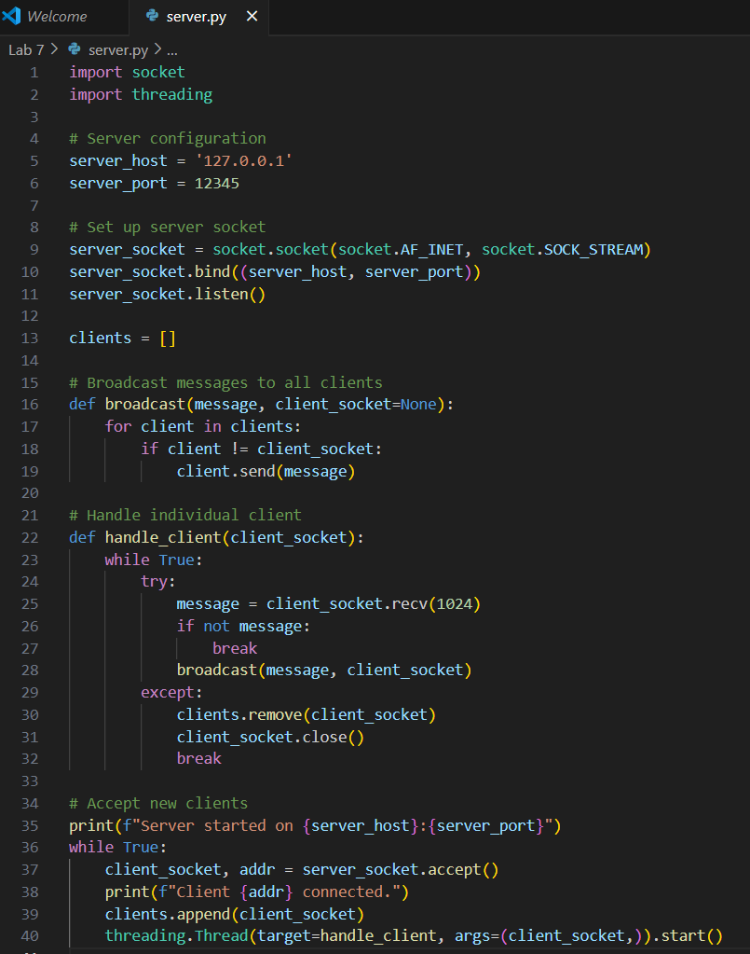

Code for client

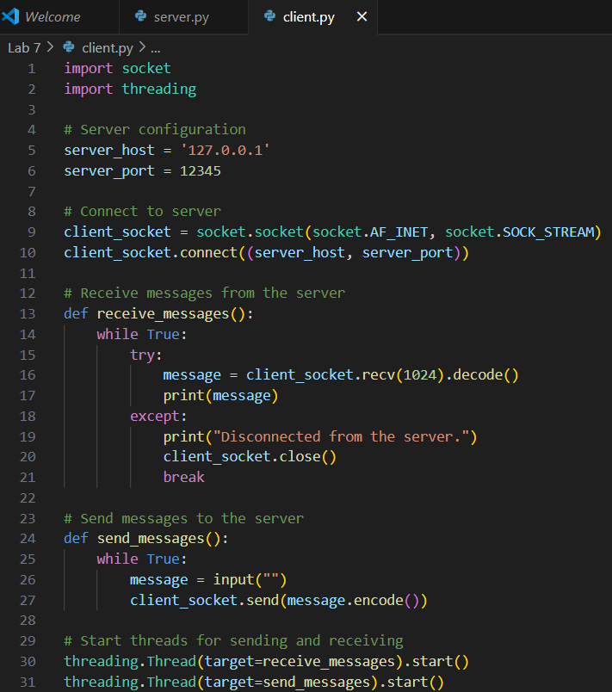

Output :-

I had executed the code for the server. There were 2 clients with IP addresses - ‘10.0.6.55’ and ‘10.0.0.2’.

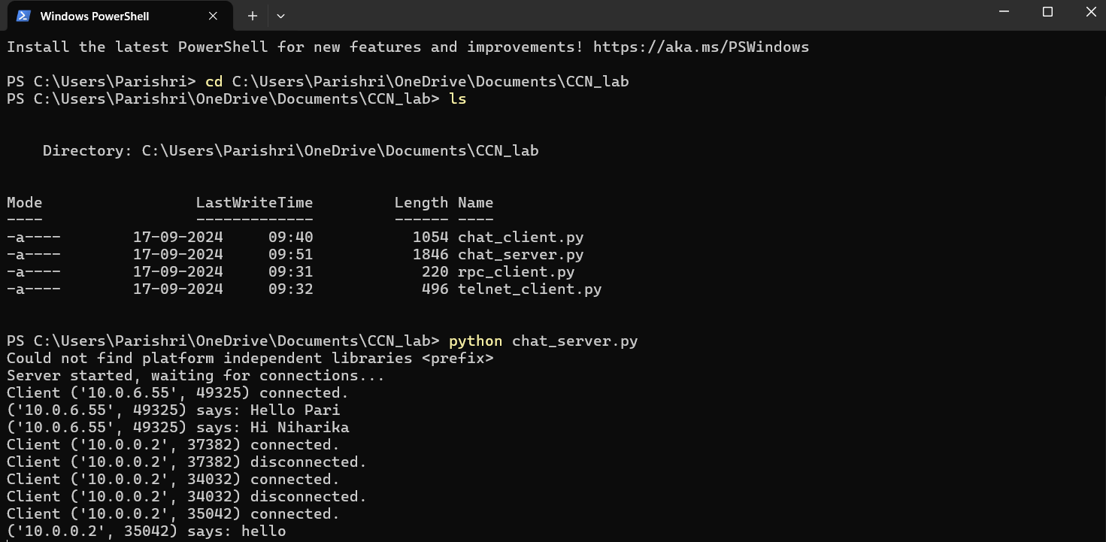

2: Remote Procedure Calls (RPC)

Code for server

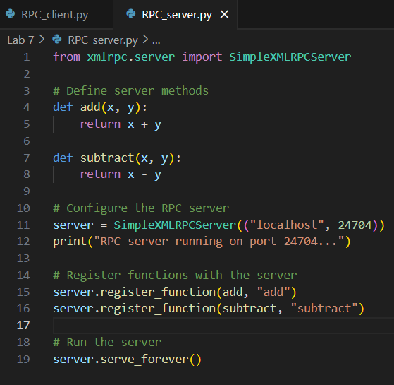

Code for Client

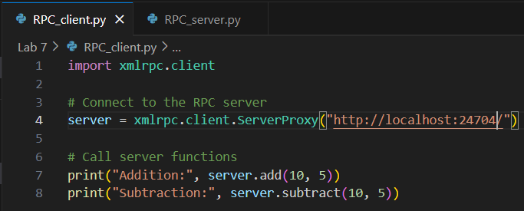

Output :-

Hosted the RPC server on port 24704.

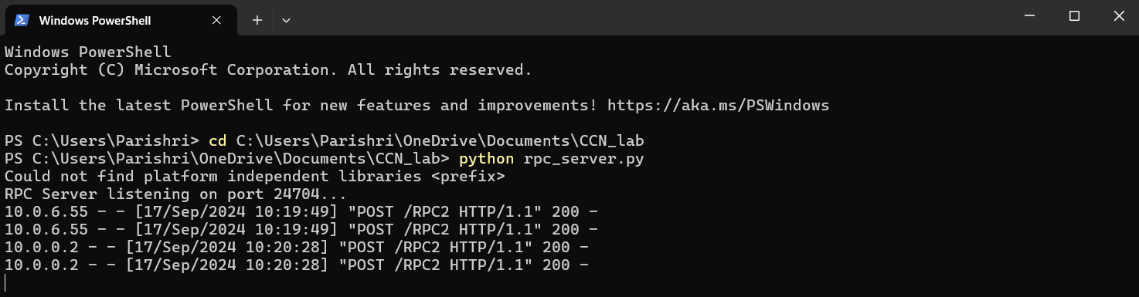

3: Telnet for controlling remote devices

Code for server

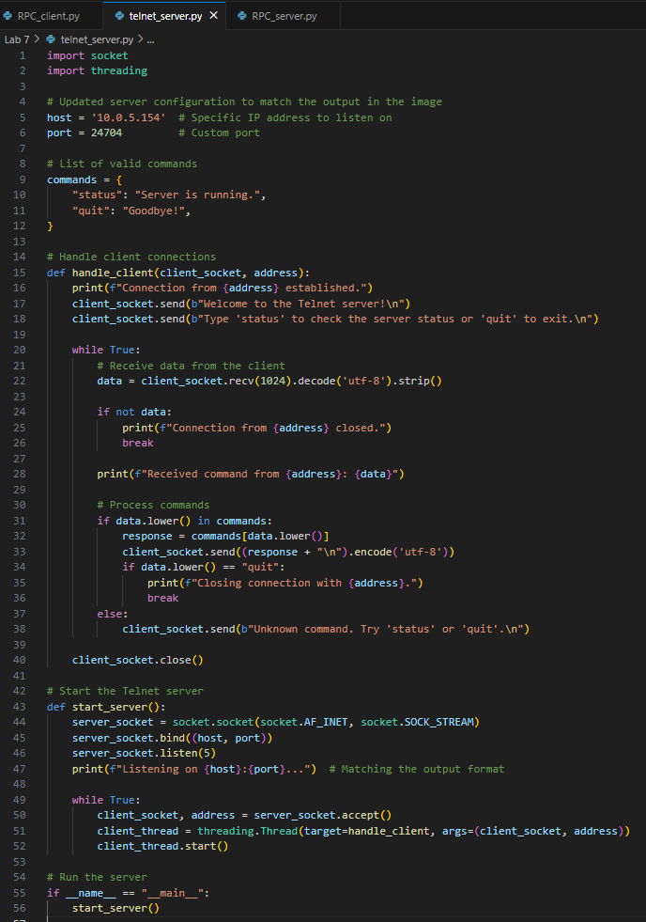

Output :-

The telnet server was listening on IP address ‘10.0.5.154’ with port number 24704

